

UNDERGRADUATE PROJECT PROGESS REPORT

|  |  |
| --- | --- |
| **Project Title:** | An intelligence recommendation system for online food ordering platform based on Collaborative Filtering |
| **Surname:** | **Quan** |
| **First Name:** | **zhihao** |
| **Student Number:** | **202018010410** |
| **Supervisor Name:** | **Monty Mu** |
| **Module Code:** | **CHC 6096** |
| **Module Name:** | **Project** |
| **Date Submitted:** | **2023/12/26** |

**Table of Contents**

1 Introduction 3

1.1 Background 3

1.2 Aim 3

1.3 Objectives 3

1.4 Project Overview 4

1.4.1 Scope 4

1.4.2 Audience 4

2 Background Review 5

3 Technical Progress 7

3.1 Approach 7

3.1.1 Software development model: 7

3.1.2 Requirement collect method: 9

3.2 Technology: 9

3.3 Testing and Evaluation Plan 9

3.3.1 Unit Testing: 10

3.3.2 Integration Testing: 10

3.3.3 Functional Testing: 10

3.4 Design and Implementation 10

4 Project Management 15

4.1 Activities 15

4.2 Schedule 16

4.3 Project Version Management 16

4.4 Project Data Management 16

4.5 Project Deliverables 17

5 Professional Issues and Risk: 18

5.1 Risk Analysis 18

5.2 Professional Issues 19

5.2.1 Legal Issues 19

5.2.2 Social Issues 19

5.2.3 Ethical Issues 20

5.2.4 4. Environmental Issues 20

6 References 20

# Introduction

## Background

In the era of highly developed information technology and logistics industry, online food delivery has become a new trend sweeping the world[1]. In online food platform, customers can browse menus, place orders, and pay for meals via websites or mobile applications.

However, the increasing health consciousness of consumers and their growing demand for healthy and sustainable food options has become a major trend in the online food delivery market. As a result, online food delivery platforms need to respond by offering a wider range of healthy and sustainable food choices. [1] However, too many kinds of products will make it difficult for users to find the information they like. Over time, user interest in the platform will decrease. [2]

In order to solve the problem of information overload, the use of recommender systems has become an effective technical choice [3]. Based on collaborative filtering, this project provides personalized product recommendation for customers through intelligent recommendation system, so as to improve user experience and enhance customer satisfaction. Collaborative filtering is a data-driven recommendation algorithm, which realizes accurate product recommendation by analyzing user preferences. This integration method is expected to provide users with more accurate and personalized recommendation services and effectively deal with the challenge of information overload. [2]

## Aim

The primary aim of this project is to implement a collaborative filtering (CF) recommendation system based on user behavior data. Our goal is to enhance the user experience of the ordering platform by providing highly personalized and targeted food recommendations.

## Objectives

The object are as follows:

1. Research on existing recommendation system algorithm.
2. Perform In-Depth Analysis of Online Ordering Platform Functions.
3. Prioritize the functionality of the designed website.
4. Evaluate and Select an Optimal Recommendation System Algorithm.
5. Identify and Acquire a Relevant Dataset for Collaborative Filtering Training.
6. Implement Core Features of the Online Food Ordering Website.
7. Construct an Intuitive and Effective Product Recommendation System Model.
8. Implement and improve the UI of the website.
9. Testing all modules and documenting & analyzing the performance of the recommended systems.

## Project Overview

### Scope

The objective of this software development project is to build an Online Food Ordering and Delivery Platform equipped with an intelligent recommendation system. This platform aims to enhance the efficiency of consumers' food exploration by offering a different of food options. The software will facilitate customers in browsing, searching, and placing orders online, while also providing personalized food and restaurant recommendations based on individual customer interests. Additionally, restaurant owners will have access to a comprehensive system allowing them to view order details and customer information.

* How It Works:

Customers will access the platform via a user-friendly interface, where they can explore a different of foods, place orders, and make secure online payments.

Recommender systems analyze customer behavior (e.g., ratings) and historical data to make personalized food and restaurant recommendations.

Restaurant owners can view and manage online order information through their merchant account to improve their operational efficiency.

### Audience

This software development project primarily targets two key audience groups—restaurant merchants and customers. The designed system aims to cater to their specific needs, providing a seamless and personalized online food ordering experience.

* Customer:

The system focuses on providing a user-friendly platform with personalized recommendations, making the food selection process more convenient and enjoyable.

* Vendor / Restaurant owner:

The system enables restaurant owners to effectively present their products, capture valuable customer insights, and leverage the recommender system to improve customer satisfaction. At the same time, it can help the restaurant advertise, improve its awareness and increase turnover [3].

# Background Review

With the continuous development of Internet services, we are facing the challenge of information overload. Recommender systems are an algorithm designed to cope with this problem. They are designed to assist individuals in finding the choice that best matches their individual interests and preferences in a variety of contexts from a vast collection of options and information [4].

In e-commerce recommendation systems, collaborative filtering is a common method to recommend products by analyzing user behaviors and preferences. It works by collecting user rating feedback for a given scope of items, and then exploiting the similarity of the rating behavior of multiple users to determine how to recommend items [5].

* Approach of Recommendation-System:

There are two main types of collaborative filtering approaches: user-based collaborative filtering and item-based collaborative filtering [5].

Item-based filtering (ItemCF) is a recommendation system generation method, which usually generates accurate recommendation results based on user characteristics and specific preferences, without considering ratings and other user preferences. In other words, the method recommends similar items to those users with a specific propensity [4]. It exploits the similarity between items to recommend relevant elements based on the preferences of a particular user.

On the other hand, the principle of user-based collaborative filtering is based on the ratings given by the users to the restaurants, usually using Pearson correlation or Angle cosine to determine the similarity between users. Based on the similar tastes between similar users, similar good restaurants are recommended [3].

* Analysis of existing food delivery platforms:

Online food ordering platforms have become increasingly popular in recent years, revolutionizing the way customers order food and receive delivery. Several companies, including Meituan, Ele. me and Uber eats, are commercial giants in the food delivery platform space, with Meituan and Ele.me being the most used delivery software in China [6]. These platforms have transformed the food industry, providing consumers with an easy and convenient way to order food online.

Therefore, in order to analyze and investigate the characteristics of Online food ordering platforms, Table 1 below shows some functional comparisons of the three platforms. Through comparison, it is found that the basic functions of search, recommendation, purchase, shopping cart and order management are well implemented on the three platforms, while the payment methods are different due to different countries. It is worth noting that Uber eats performs better than the other two software in terms of Delivery Method and schedule.

|  |  |  |  |
| --- | --- | --- | --- |
| Feature Comparison | MeiTuan food delivery [7] | Ele.ME [8] | Uber eats [9] |
| Register required Information | **Phone number** | **Phone number** | **Email &**  **Phone number** |
| Shopping Cart | **YES** | **YES** | **YES** |
| Search restaurants | **YES** | **YES** | **YSE** |
| Search foods in restaurant page | **YES** | **YES** | **NO** |
| Favorite function | **YES** | **YES** | **YES** |
| Modify personal information | **YES** | **YES** | **YES** |
| Delivery Method | **Delivery** | **Delivery** | **Delivery & Pickup** |
| Schedule pickup | **NO** | **NO** | **YES** |
| Recommended  Restaurants | **YES** | **YES** | **YES** |
| Address Management | **YES** | **YES** | **YES** |
| Order view | **YES** | **YES** | **YES** |
| Payment method | **Alipay, Wechat payment, Meitun payment** | **Alipay, Wechat payment, China unionpay** | **Paypal, Cash, Credit card** |
| Customer rating function | **YES** | **YES** | **YES** |

Table 1: Feature comparison between different platforms

# Technical Progress

## Approach

### Software development model:

In the choice of software development model, the waterfall model is a common and classic development model, which shows the software development process in linear order. As shown in Figure 1 below, the software development process can be divided into seven parts in linear order: Requirement Analysis, System design, Model selection, Implement the system, system integration, test, system operation and maintenance.

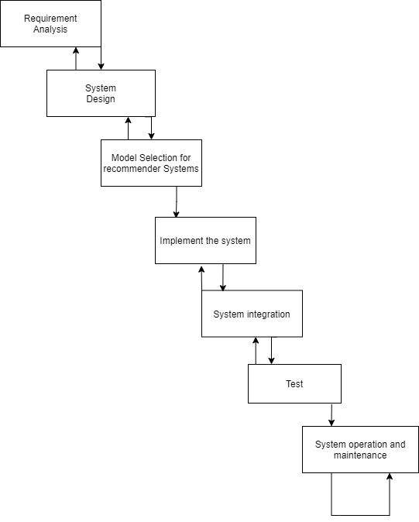

Figure 1: Waterfall model

### Requirement collect method:

* Market research: Utilize websites like statista to study the relevant market and competitors to understand the needs and preferences of users across the market. Relevant information can be obtained by investigating industry reports, data from market research agencies, and product analysis from competitors.
* User observation: Observe the behaviors and interactions of friends and classmates around when using the online takeout platform, so as to obtain the needs and problems of users in actual usage scenarios.
* Analysis for competitive products: Observe the popular online ordering software (Meituan, Ele.me, uber eats etc.) recorded to analyze which requirements are the most needed by users.

## Technology:

The hardware used in the project are as follows:

**Hardware**:

* Computer: ASUS Tianxuan
* CPU: R7-4800H
* Random Access Memory: 16GB

The software used in the project are as follows:

**Software:**

* Language: Python, Javascript
* IDE: Pychram
* Database: Mysql 8.0, Mysql workbench, Navicat
* Backend framework: Django
* UI: Javascript, Html, Css, JQuey, Bootstrap
* Operating system: windows 10
* Algorithm Model: Collaborative Filtering Algorithm

**Data set:**

Url: <https://www.kaggle.com/datasets/kmader/food41>

## Testing and Evaluation Plan

In this section, the testing and evaluation plan for the online food delivery platform will follow a Test-Driven Development (TDD) approach to ensure the robustness, functionality, and performance of the system. The plan will encompass various testing techniques, including acceptance testing, integration testing, unit testing, functional testing.

### Unit Testing:

Objective: Validate the platform's user-friendliness.

Testing Tools: Django Testing Framework: django.test.TestCase

Test Cases:

* Verify that the user account creation feature is working correctly.
* Check that the restaurant information update logic is correct.
* Test order processing functionality, including order creation and status updates.

### Integration Testing:

Objective: To ensure that software components or features function together.

Tools: Django's Built-in Testing Framework, pytest-django

Test Cases:

* Verify the interaction between user interface and backend services.
* Test the integration of the payment gateway to ensure smooth transaction processes.
* Check the integration of the recommendation system with the user interface to ensure recommendations accurately reflect user preferences.
* Use pytest-django for testing database transaction management, ensuring transactions are correctly executed.

### Functional Testing:

Objective: To check functionality based on business scenarios derived from functional requirements.

Testing Tools: Selenium, Django's Built-in Testing Framework

Test Cases:

* Use Selenium to simulate user activities on the platform, such as browsing, ordering, and payment.
* Test the user registration and login process, verifying user interface elements and workflows.
* Validate the functionality of the user feedback and review system.
* Check the search and filter functionalities, ensuring users can find restaurants and dishes based on different criteria.

## Design and Implementation

* Investigation on the Construction and User of Existing Food Delivery Platform Software

Research Objectives: Clearly defined goals and scope for studying existing food delivery platform software construction and user orientation.

Survey Samples: Selected prominent global food delivery platforms such as Meituan, Ele.me, and Uber Eats for analysis.

Market Research: Utilized market research tools like Statista to investigate market size, growth trends, and user distribution.

Function Analysis: Downloaded and analyzed features of selected food delivery platform software.

Recommender Systems: Investigated how these platforms recommend products, including algorithms, personalization, and user feedback.

Findings Summary: Summarized key discoveries regarding construction and user orientation of existing food delivery platform software.

* Development Environment Configuration

Django Framework Setup: Downloaded and installed the Django web framework.

Django-Mysql Connection: Configured the development environment by connecting Django to MySQL.

* Database Design

Data Requirement Analysis: Determined the type of data, structure, and relationships needed based on user requirements.

Logical Model Design: Designed the logical model of the database.

SQL Implementation: Created a preliminary MySQL SQL file for database implementation

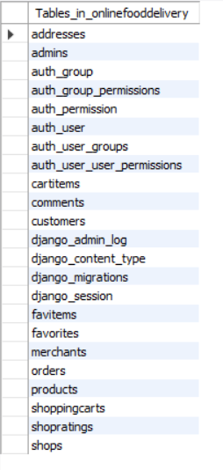

Figure 2: Database structure

* Index Page Design and Implementation

Index Page Design: Designed the layout of the index page for customers and merchants.

Customer Index Page Features: Implemented search bar, menu, shopping cart, favorites, and personal information sections.

Merchant Index Page Features: Implemented mystore, myorders, and personal information sections.

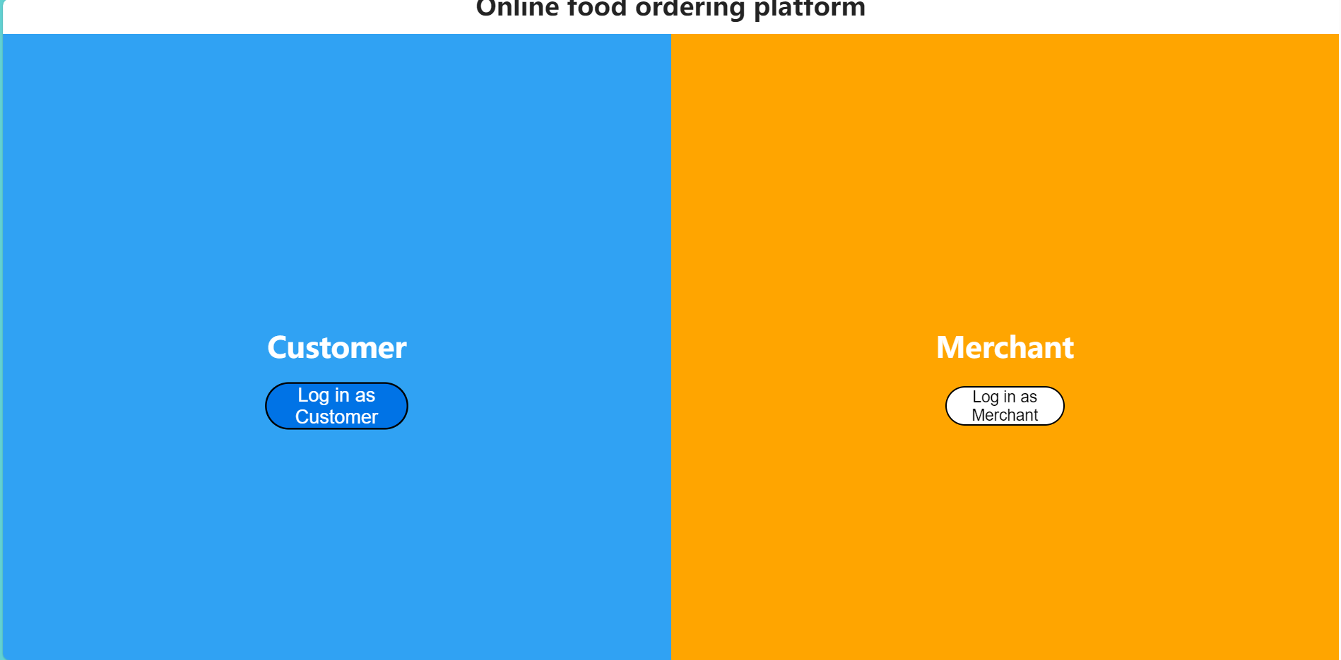

Figure 3: Index page

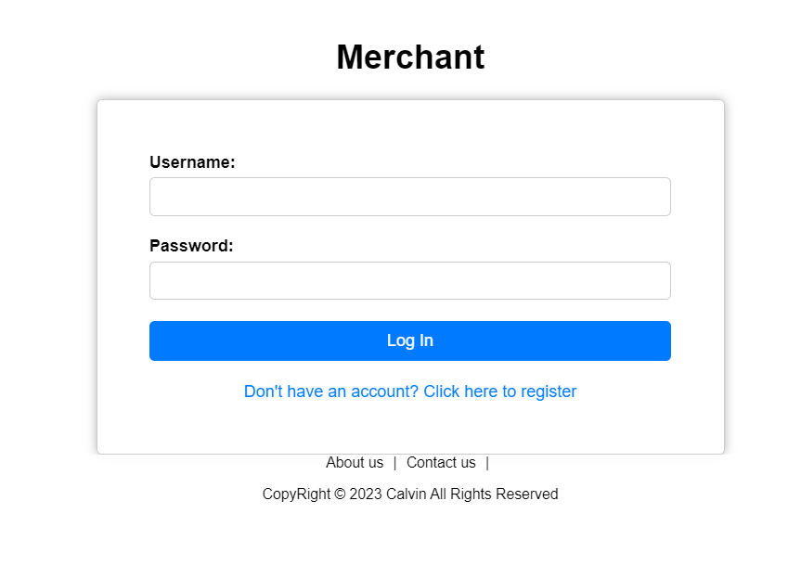

Figure 4: login page of merchant

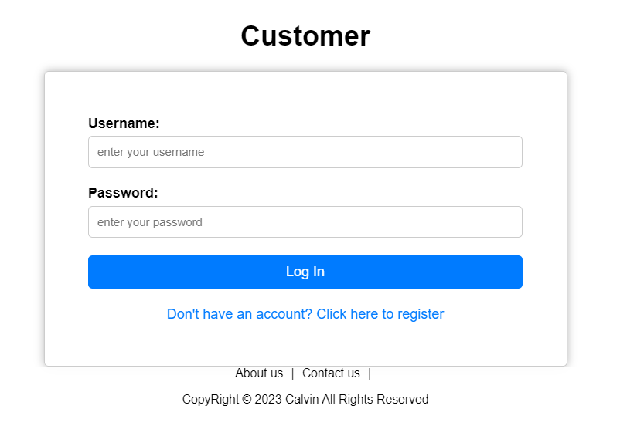 Figure 5: login page of customer

* Requirement Analysis and System Design

Function Collection and Analysis: Collected and analyzed functions from competing software (e.g., Ele.me, Meituan).

Core Function Identification: Identified the core functionality of competing software.

Module-based Function Division: Divided functions into modules and visualized them in a mind map.

User-based Feature Differentiation: Differentiated features by user type and importance in a mind map.

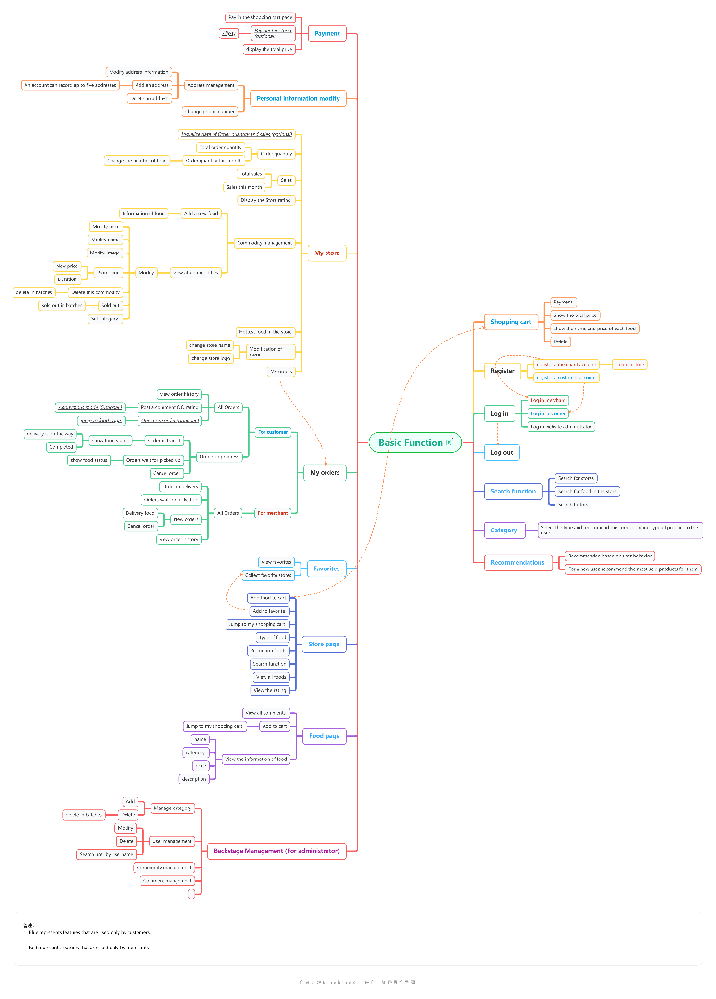

Figure 6: Project function & system design

# Project Management

## Activities

|  |  |  |
| --- | --- | --- |
| Objective | Status | Detail |
| Investigation on the Existing Food Delivery Platform | Completed | Researched prominent food delivery platforms (Meituan, Ele.me, Uber Eats). |
| ii. Comparison between food delivery platforms | Completed | Compared features, market positions, and user feedback of selected platforms. |
| iii. Research on Collaborative Filtering (CF) | Completed | Conducted research on collaborative filtering algorithms and methods. |
| iv. Determine a feasible recommender system model | Completed | Explored and determined a suitable collaborative filtering model. |
| v. Write Project proposal | Completed | Developed and submitted a comprehensive project proposal. |
| vi. Requirement analysis | Completed | Analyzed and documented software requirements for the platform. |
| vii. System design (Split the system into modules) | Completed | Designed the system architecture, splitting it into modular components. |
| viii. Implementation (Implement the front-end and back-end) | In Progress | Currently implementing the front-end and back-end of the online food delivery platform. |
| ix. Implement the recommend function | In Progress | Implementation of user-based collaborative filtering recommendation algorithm |
| x. Test and evaluate the recommend function | Not Started | Planned testing and evaluation for the collaborative filtering recommendation. |
| xi. System testing & performance analysis | Not Started | Planned comprehensive testing of the entire system. |
| xii. Write Final report | Not Started | Will write the final report summarizing the entire project. |
| xiii. Create Poster | Not Started | Will design and create a poster for project presentation. |

Table 2: Activity table

## Schedule

The schedule of the project is shown in figure 7 below:

The blue part indicates the completed activity.

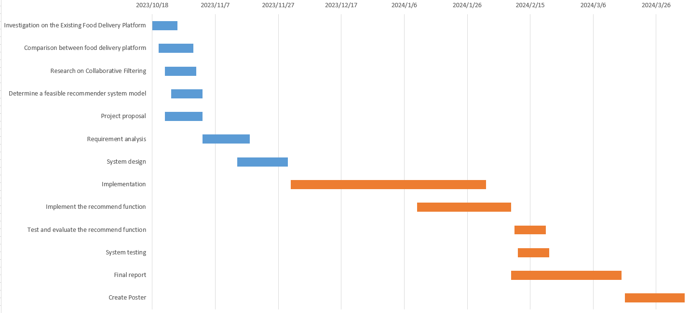

Figure 7: Gantt chart of activity

## Project Version Management

I used the github platform as the software for project version management, and created a repository on it to manage all my code.

I use git to manage all the files used in the project.

Here is Github url: <https://github.com/Blueblue22two/202018010410_project_recommendation-system>

## Project Data Management

* For Weekly reports, I upload them to the Weekly report folder every week.
* Upload all the reports to the Reports folder.
* Upload all the Reference files to the References folder.
* Upload all the code to a code file and do version management.
* Upload other files (such as charts) to the others folder.
* Upload the files related to Presentation to the Presentation folder.
* Upload UI-related files to the UI folder.

The figure 8 below shows the file format in the repository in detail.

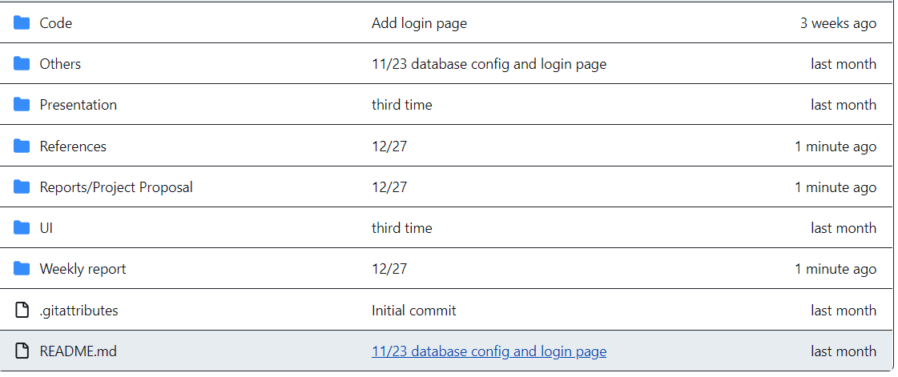

Figure 8: Github Repository format

## Project Deliverables

* Project proposal
* Progress report
* Final report
* Weekly report
* Ethical form 1
* References
* Project Code (include development software list)
* Presentation (pdf, image, video)

# Professional Issues and Risk:

## Risk Analysis

This section shows a risk analysis and mitigation strategies for the project.

|  |  |  |  |  |  |  |  |  |
| --- | --- | --- | --- | --- | --- | --- | --- | --- |
| Risk ID | Potential Risk | Cause ID | Potential Causes | Severity | Likelihood | Risk | Mitigation ID | Mitigation |
| R1.1 | User dissatisfaction with recommendation system | C1.1.1 | Poor algorithm performance | 3 | 3 | 9 | M1.1.1 | Regularly evaluate and update the recommendation algorithm based on user feedback and usage patterns. |
| C1.1.2 | Inadequate user data collection | 2 | 2 | 4 | M2.1.2 | Implement robust data collection mechanisms and ensure transparency in data usage policies to gain user trust. |
| R1.2 | Low user engagement with the platform | C1.2.1 | Limited variety of restaurants and cuisines | 3 | 2 | 6 | M1.2.1 | Expand the range of available restaurants and cuisines through partnerships and collaborations. |
| C1.2.2 | Poor user interface design | 2 | 3 | 6 | M1.2.2 | Invest in user experience design and conduct usability testing to enhance the platform's ease of use. |
| R1.3 | Technical infrastructure issues | C1.3.1 | Unanticipated scalability challenges | 4 | 3 | 12 | M1.3.1 | Conduct thorough scalability testing and implement scalable architecture from the beginning. |
| C1.3.2 | Third-party service failures | 3 | 2 | 6 | M1.3.2 | Have backup plans and redundancies for critical third-party services. |
| R1.4 | Security vulnerabilities | C1.4.1 | Poor data encryption practices | 4 | 3 | 12 | M1.4.1 | Implement strong encryption methods for sensitive user data. |
| C1.4.2 | Insufficient user authentication measures | 3 | 2 | 6 | M1.4.2 | Enhance user authentication protocols and incorporate multi-factor authentication. |
| R1.5 | Legal and regulatory compliance issues | C1.5.1 | Inadequate understanding of local food safety regulations | 3 | 3 | 9 | M1.5.1 | Engage legal experts to ensure compliance with local food safety regulations and standards. |
| C1.5.2 | Privacy concerns and data protection laws | 4 | 2 | 8 | M1.5.2 | Implement robust privacy policies and obtain explicit user consent for data processing. |

Table 3: Risk table

## Professional Issues

### Legal Issues

Identification:

In the context of our online food delivery platform project, legal issues primarily revolve around Intellectual Property Rights (IPR), Health & Safety (H&S), and compliance with data protection laws, including GDPR.

Discussion:

IPR: Careful attention will be given to the use of proprietary information and software. Unauthorized use may lead to legal consequences, necessitating thorough validation of research documents, source code, and external libraries. Compliance with licenses such as MIT License and copyright laws is crucial for lawful use.

Data Protection (GDPR): Adherence to GDPR regulations is paramount, ensuring the secure handling of user data, privacy, and informed consent.

### Social Issues

Identification:

Social issues in our project involve considerations of social responsibility and the prevention of unintended biases and discriminatory behavior.

Discussion:

Social Responsibility: The application's design and development will adhere to the Web Accessibility Initiative, ensuring accessibility, user-friendliness, and inclusivity for all users.

### Ethical Issues

Identification:

Ethical considerations focus on the responsible use of research and developments, particularly emphasizing educational and research purposes and avoiding risks associated with malfunctioning Machine Learning (ML) models.

Discussion:

Educational and Research Purpose: Emphasis on the strictly educational and research-oriented nature of the project to mitigate risks associated with ML models.

Avoidance of Commercial Use: Clear communication that the product is not for commercial use and should not influence or affect financial or investment decisions.

### Environmental Issues

Identification:

While not explicitly stated in the given material, environmental issues may arise from the potential environmental impact of the project.

Discussion:

Environmental Impact: Consideration of the project's environmental impact, such as energy consumption and resource usage, to minimize any negative effects.

# References

[1] Statista Market Insights, ‘Online Food Delivery: market data & analysis’, Statista Market Insights, Mar. 2023. Accessed: Oct. 30, 2023. [Online]. Available: https://www.statista.com/study/40457/food-delivery/

[2] X. Li, ‘Research on the Application of Collaborative Filtering Algorithm in Mobile E-Commerce Recommendation System’, in *2021 IEEE Asia-Pacific Conference on Image Processing, Electronics and Computers (IPEC)*, Dalian, China: IEEE, Apr. 2021, pp. 924–926. doi: 10.1109/IPEC51340.2021.9421092.

[3] L. Wang and B. Yi, ‘Research on O2O take-away restaurant recommendation system: taking ele.me APP as an example’, *Cluster Comput*, vol. 22, no. S3, pp. 6069–6077, May 2019, doi: 10.1007/s10586-018-1814-y.

[4] C. N. Sánchez, J. Domínguez-Soberanes, A. Arreola, and M. Graff, ‘Recommendation System for a Delivery Food Application Based on Number of Orders’, *Applied Sciences*, vol. 13, no. 4, p. 2299, Feb. 2023, doi: 10.3390/app13042299.

[5] H. Liu, ‘Implementation and Effectiveness Evaluation of Four Common Algorithms of Recommendation Systems - User Collaboration Filter, Item-based Collaborative Filtering, Matrix Factorization and Neural Collaborative Filtering’, in *2022 International Conference on Cloud Computing, Big Data Applications and Software Engineering (CBASE)*, Sep. 2022, pp. 224–227. doi: 10.1109/CBASE57816.2022.00049.

[6] Statista, ‘Catering-services-in-china’, Statista. Accessed: Nov. 01, 2023. [Online]. Available: https://www.statista.com/study/63164/catering-services-in-china/

[7] ‘Meituan Waimai’. Meituan.

[8] ‘Ele.me’. Ele.me.

[9] ‘Uber Eats’. Uber Eats.